READ ME

Recommended configuration

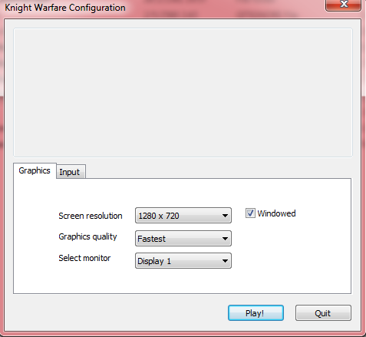

Main Menu

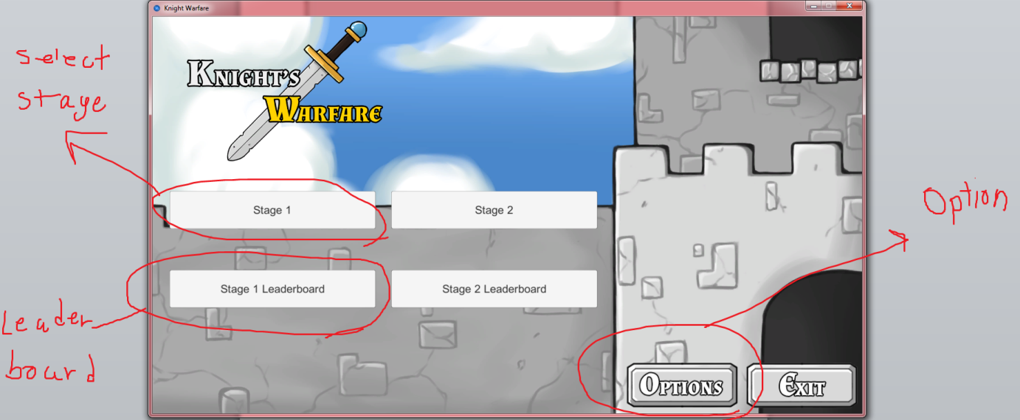

Option

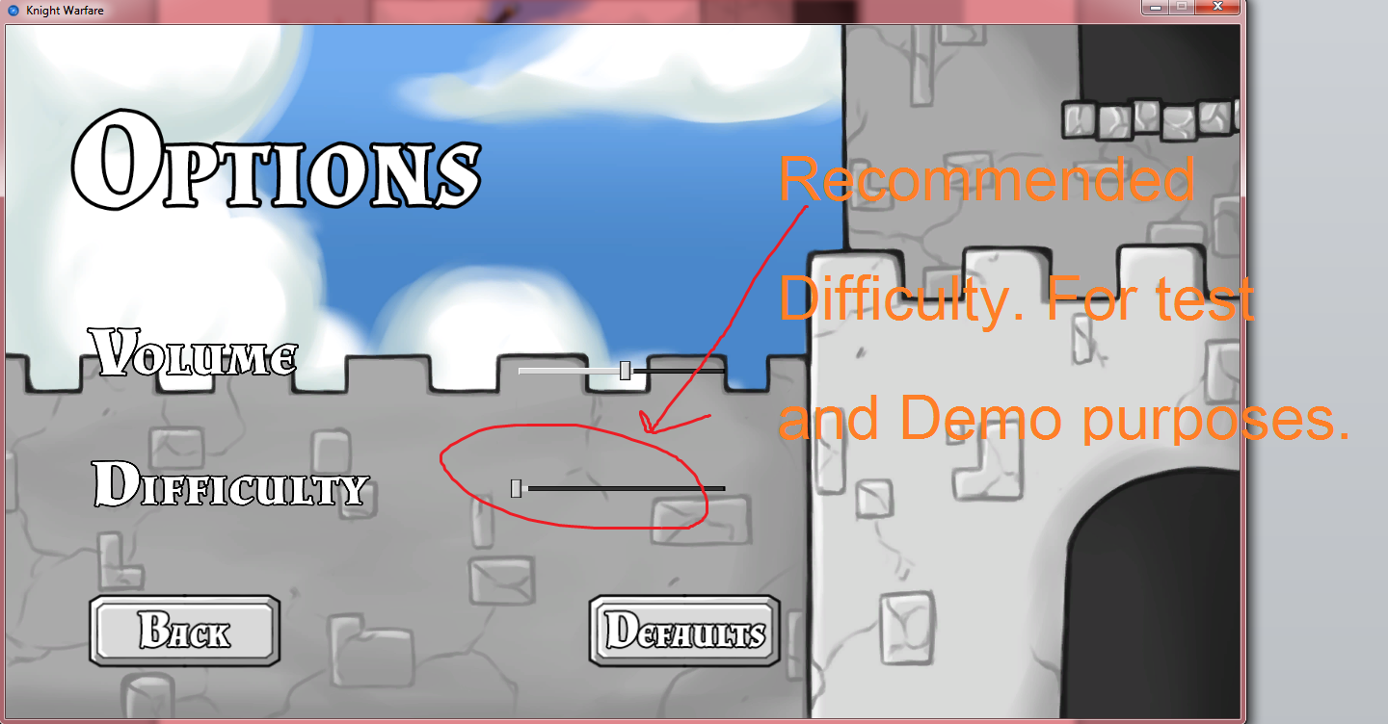

Gameplay

-click the tower to select

-click the grid to summon the selected tower

-don’t let the monster get to the left

-Mana(600 in picture) is both SCORE and CURRENCY to buy tower

-Detailed gameplay in the video. Please watch the video for further detail.

https://youtu.be/yrXsBJwiAtE?t=3m59s

\*\*\*\*easiest difficulty recommended\*\*\*\*\*\*

